**Experiment 3: JavaScript**

**Aim:** Basic program to depict JavaScript.

**Tags Used:**

<script>

Document.getElementById()// function

**Implementation:**

**Output**

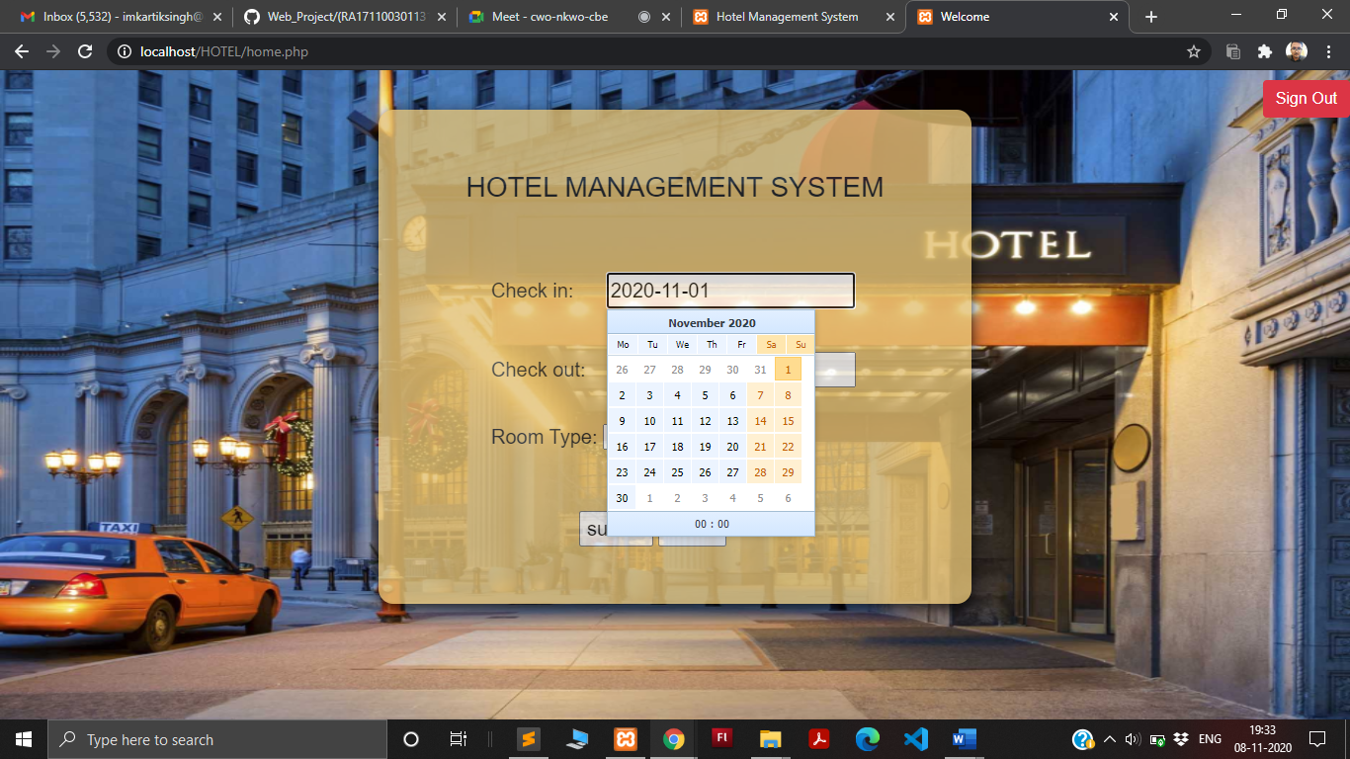

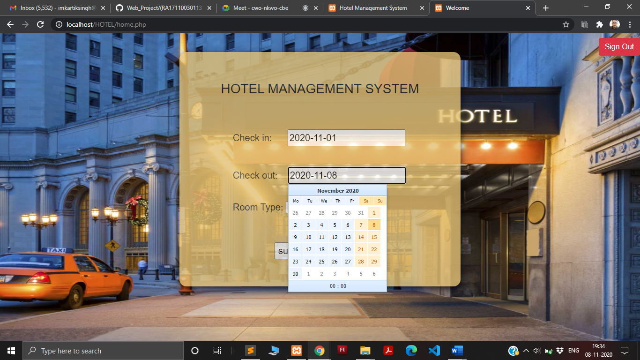

**Code**

<!DOCTYPE html>

<html lang="en">

<head>

<meta charset="UTF-8">

<title>Welcome</title>

<link rel="stylesheet" href="https://stackpath.bootstrapcdn.com/bootstrap/4.4.1/css/bootstrap.min.css" integrity="sha384-Vkoo8x4CGsO3+Hhxv8T/Q5PaXtkKtu6ug5TOeNV6gBiFeWPGFN9MuhOf23Q9Ifjh" crossorigin="anonymous">

<link rel="stylesheet" type="text/css" href="dhtmlxcalendar.css"/>

<script src="dhtmlxcalendar.js"></script>

<style type="text/css">

body

{

font-size: 20px;

font-family: 'Arial';

padding: auto;

margin-top: 10px;

background-color: black;

background-image: url('bg.jpg');

background-size: 1400px 680px;

opacity: 120%;

}

.container

{

max-width: 600px;

padding: 14px 14px 14px 14px;

box-shadow: 0 4px 8px 0 rgba(0, 0, 0, 0.5), 0 6px 20px 0 rgba(0, 0, 0, 0.8);

align-self: center;

background-color:#E2C073;

border-radius: 15px;

align-self: left;

height:500px;

opacity: 80%;

}

</style>

<script>

var myCalendar;

function doOnLoad()

{

myCalendar = new dhtmlXCalendarObject(["calendar","calendar2",]);

}

</script>

</head>

<body onload="doOnLoad();"style="">

<div class="m-auto d-block" style="float: right;">

<a href="logout.php" class="btn btn-danger m-auto">Sign Out</a>

</div>

<br>

<div class="container" style="text-align:center height:100px;">

<div style=" padding-top: 48px; padding-bottom: 32px;">

<h3 style="text-align:center" >HOTEL MANAGEMENT SYSTEM</h3>

</div>

<div style="padding-left:100px">

<div id="check">

<br>

<form action="check.php" method="post">

<div style="position:relative;height:80px;">

<label for="in">Check in:</label> &nbsp;&nbsp;&nbsp;&nbsp;

<input id="calendar" name="in" placeholder="2015-06-02" required="" type="text"> <br><br>

</div>

<div>

<label for="in">Check out:</label> &nbsp;&nbsp;

<input id="calendar2" name="out" placeholder="2015-06-05" required="" type="text"> <br><br>

</div>

<div>

Room Type:

<select name="room">

<option value="A/C">A/C</option>

<option value="Non-A/C">Non-A/C</option>

</select>

<select name="type">

<option value="single">Single</option>

<option value="double">Double</option>

<option value="three">Three</option>

</select>

</div>

<br><br>&nbsp;&nbsp;&nbsp;&nbsp;&nbsp;&nbsp;&nbsp;&nbsp;&nbsp;&nbsp;&nbsp;&nbsp;&nbsp;&nbsp;&nbsp;

<input type="submit" name="submit" value="submit" />

<input type="reset" name="reset" value="Reset" />

</form>

</div><!--check -->

</div>

</div>

</body>

</html>

**Result:**The experiment was successfully completed.